Prologue

Down through the ages there are periods where everything seems to go right. They seem to be far less frequent than those times when everything seems to go wrong. These periods of what the French call joie de vivre are hallmarked by great advancements in the arts, industry and sciences. Sadly, these periods of joie de vivre are rarely appreciated until much later, usually in those periods when everything is going wrong.

One such period, perhaps the greatest of them all is now referred to as La Belle Époque, or the beautiful times. In 1871, the Franco-Prussian War came to an end and with it an almost continuous period of war in Western Europe going back centuries. Until the Great War over 40 years later, Western Europe was at peace. It seems that peacetime is a common thread with joie de vivre being associated with the Roaring 20s and the post-World War II era.

La Belle Époque was the greatest period of cultural, scientific and industrial growth that the world has ever known, and the symbolic monuments of the era were its World’s Fairs. Amazingly between 1871 and 1914 there were over 120 World’s Fairs held. Many were regional in their scope, but all proclaimed the new world order of peace, prosperity and advancement. Of the many events, there are three that stand out and remain inspirations to this day. The first was the Centennial Exposition in Philadelphia of 1876, which among other things gave us the telephone and the typewriter, arguably among the top ten inventions in the history of mankind. The third was the World’s Columbian Exposition in Chicago 1893, the Great White City that birthed the concept of American Exceptionalism. The second was the Exposition Universal of 1889 held in Paris.

While the Centennial Exposition ushered in the modern Industrial Revolution, and the Columbian Exposition was the genesis of the City Beautiful movement and modern city planning, the Exposition Universal gave us the greatest gift that humanity could receive… imagination.

January 1, 1889

1889 started auspiciously. The solar eclipse that traversed the western portion of America was not thought to be a harbinger of things to come, and few actually saw it. But even to those who missed this midday darkening, the year 1889 was to bring forth a world of darkness and light, excitement and tragedy.

I actually saw the eclipse in Reno, Nevada, a little way north of town. I was on my way back to Chicago after visiting San Francisco on assignment for the New York Herald. Gordon-Bennett actually wired me from Paris with instructions to photograph the eclipse.

I had never seen a total eclipse, and it was quite a sight. The sun, which glared brilliantly off of the snow, subtly dimmed until almost total darkness. The sounds of the surrounding area were muted with every passing second. Nature, and those who live by the sun, believed that nightfall had arrived. But in no time at all, the sun reclaimed the day, and all was normal again. In retrospect, the advent of 1889 in America’s mountainous west did little to portend the tragedies that would engulf the region when the year ended.

I took the wagon that I had hired back to town to wait for the Overland Flyer. Five days later I was in Chicago and two days after that in New York. The trip was amazing, and the train luxurious, but it was cold. There was always wind, from the plains of Kansas to the Great Lakes, and while the Pullman car deflected the wind, the view out my sleeper window made me shiver.

Back in New York on January 9th, I headed to the Herald’s offices at Broadway and Ann Street. I had hoped to spend the next few days unwinding and enjoying friends and nightlife. New York was a thriving city in what Mark Twain had called the Gilded Age. Led by industrialists like Vanderbilt, Rockefeller and Jay Gould, America was seeking its place as the great nation of the world. The railroads had opened America; ten years ago, I could not have imagined traveling from coast to coast in the luxury of a Pullman train.

With more than half the country inhabited only by nomadic tribes, new citizens bound for the open West were arriving every day and New York was teeming with all sorts of Irishmen, Italians, and Germans. The best parts of Manhattan were still in the lower end of the island. Manhattan had started here and expanded northward. The arrival of immigrants throughout the 19th century had seen ethnic neighborhoods spring up as the city grew in size.
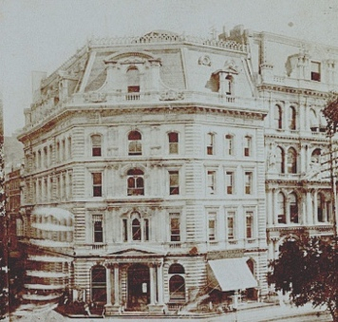
The New York Herald Building
Most of my friends in the newsroom were anxious to hear about my journey, so we agreed to dine at Delmonico’s later. But before I could leave, a newsboy came into the room yelling my name. This wasn’t good I thought, and I suddenly saw my well-planned future being dashed on the rocks. Alas, when one worked for Gordon-Bennett your own time was often an illusion, and for me this was the current case.

He wanted me in Paris, by 1 February, with a stop in England on the way. The Universal Exposition was to be held in Paris starting in the spring, and I was to be the Herald’s chief photographer for all things Parisian. G-B would provide rooms and I was told to plan on a long stay, perhaps a year or more.

Being single, the new assignment was agreeable to me, but sadly left me no time for goodbyes with my parents in Buffalo. I was able to send a wire advising of my new adventure along with promises to follow-up with letters when I arrived in Paris. I suggested that they should come in the summer for a visit.

The boys in the photo department of the Herald were packing up my camera kit and promised to have it in my cabin on the assigned departure date. I was booked onto the SS City of New York; G-B always travelled well, a trait that he offered to his staff. It sailed on the 12th.

But that did give me three nights to have some fun. First, I headed back to my rooms where I notified my landlady of my imminent departure,

“You just got back!” she exclaimed. “What’s the old pisser want of you now?”

The pisser was my boss, James Gordon-Bennett JR. He currently resided in Paris, and ran the Herald from there, having made an ass of himself years ago when he decided to piss in his fiancée’s fireplace, in front of a gathering of New York’s finest, many of whom were undoubtedly still traumatized by the event. Of course, the wedding was off and in no time so was G-B.

The Herald was America’s most popular paper and having its publisher 4,000 miles away, presented problems. G–B had recently started a European daily, giving every indication that he would never return to America. As the story went, he was still wild and rebellious, it was rumored that he raced up and down the Champs Elysees in his carriage wearing nothing. As I packed, I wondered what I was getting into.

Around 7:30, I set out for Delmonico’s. America’s most famous restaurant was at 2 South William Street in Lower Manhattan, but a few blocks from the Herald’s offices. Located in an attractive eight-story building, the restaurant occupied the entire first floor. It was the favorite of many of New York’s leading citizens; indeed G-B had his own table here before his self-imposed exile.

It was a wonderful evening of dining and camaraderie highlighted by one of Delmonico’s famous cuts of beef. I was the star attraction; everyone wanted to know about San Francisco and the trip across America. Many had been to Chicago but few beyond. Some of our reporters had been across America; after all it was G-B who had funded Henry Stanley’s trip to find Dr. Livingston, but my pals at the Herald were of a different cut. These were the everyday workers who performed the magic that brought the image to the printed page. I was well known because I snapped the image, but G-B and others like him had nary a clue of what happened next and how important the photo staff. I knew that they were integral to my work and always showed my appreciation when I could. G-B didn’t know it, but he was paying for this night of fun.

The next day I hastily packed my travel cases. The Herald had accounts in France, so I was able to arrange for my somewhat paltry bank account to be transferred. The Herald had alerted the Passport office of my needs and the document was ready on the 11th. Passports were not required for travel in Europe but served as identification, especially when one found themselves on the wrong side of the law in places where English was little understood. What little I wasn’t taking with me was packed up and sent to the Herald building for storage.

On the morning of the 12th, I met someone from the Herald’s offices who handed me my tickets and an advance on my salary. G-B was a generous man at times, but he knew better then to advance money to any employee before his last night in town.

The crossing was not pleasant. Normally the Transatlantic route is laid up in the depth of winter, but with the upcoming Universal Exposition, crossings had been scheduled starting in January. The weather had cooperated, so far, the winter had been warm, and the Hudson had no ice. Of course, that had little impact on the North Atlantic route, which was its usual rambunctious self. We made it across, more or less in one piece. It seemed to be a week before my body stopped moving.

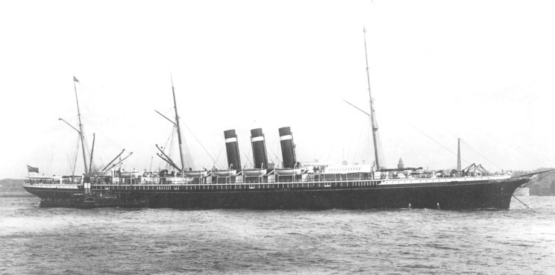
SS City of New York, twin screwed liner of the Inman Line

